We would like to point out that, in order to be consistent with the results of the article studied, we have fixed T* and n at the same time, with the aim of reproducing similar results. Below, we give additional results where we vary the parameter theta, where it was fixed in the paper studied.

The results are consistent: the greater the beta, the greater the intensity. This has the effect of increasing the power of the test, since for higher intensity values, we move away from the homogeneous case reached at \beta = 0, and this facilitates statist differentiation between our two hypotheses. This strengthens the test's prediction.

At this intensity, the results are not surprising. Once again, we are dealing with an increasing intensity. Since Weibull intensity increases less rapidly than exponential trending, we see that exponential intensity takes less time to reach a higher power.

In these two graphs, we are coherent with the studier paper. Laplace test is better than Boswell test.

From this dataset, we were able to extract the times thanks to the library providing the database. Each time corresponds to the date, day and time of the event. So we converted all these times into days, and then calculated a cumulative sum of the latter. For the moment, this allows us to display the start of the process, unchanged for the time being.

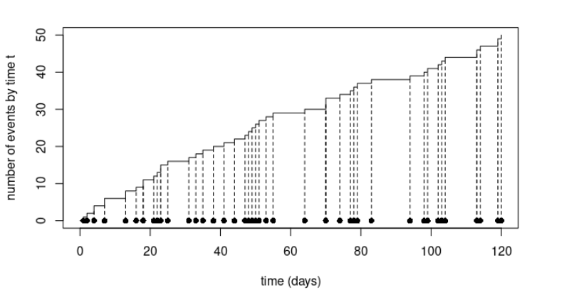

To confirm that we're dealing with a Poisson process, we need to make sure that the distribution of time intervals follows an exponential distribution and that these intervals are independent.
By fitting an exponential function to the distribution of our data, we notice that our intervals seem to follow an exponential distribution :

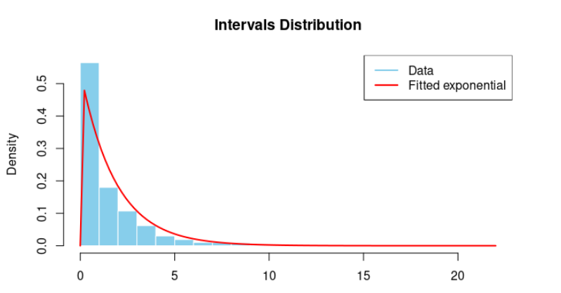

Nothing tells us that the process is homogeneous, so fitting to our data an exponential function whose parameter is constant is not scientific proof. We're just trying to legitimize the use of Laplace and Boswell Tests for this process. So far, so good.

The following graph shows that the time intervals are independent:

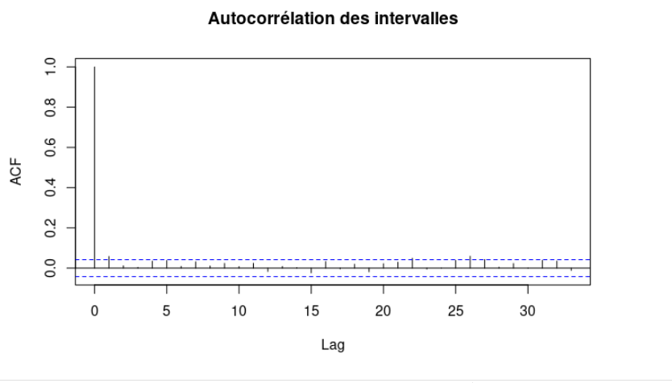

The correlation between each interval tends towards 0, so we can confidently move on to apply our tests to these data.

With a Laplace test, we obtain a p-value of approximately 1e-4, which is well below 0.005. We can therefore be 95% sure of rejecting the fact that our process follows a homogeneous Poisson process. We are therefore 95% sure that it is inhomogeneous.

As we were unable to correctly implement the p-value for the Boswell test, which is an approximation, we only made sure that we were in the rejection zone with the observed test statistic, which is the case.

